

Market Position Statement for Children with Disabilities Short Breaks and Enabling Services

Contents
Contents
What is a Market Position Statement? 3
Who is it for? 4
Local Context 5
What’s happening in Newcastle? 6
Services delivering activities to children 7
Feedback from Parents 8
Feedback from Parents 2 9
What do staff say? 10
What will we do? 11
Care Package Finances 12
Contacts 13

Background to Service Needs

In October 2015 a Market Position Statement for Children with Disabilities was circulated for consultation.

We have used the most important headlines of that document to produce this version as supporting material for the 2017 – 2020 Framework contract.

Throughout this document we have identified all of the services currently delivered to Children with Disabilities as of July 2016 but the main purpose is to show how they contribute to the overarching “Enablement Support and Short Breaks” element

It is these services we will be tendering for to enable the council to meet its duty in providing disabled children and young people with a short breaks service and support.

We will commission outcome-focused services that are designed to support personalisation by enabling the service user to achieve their aspirations and priorities.

All rights for the disabled child and duties for the local authority operate within a legal framework which covers a range of laws and regulations.

What is a Market Position Statement?
Newcastle City Council aspires to be a cooperative council. This means we want to:
- Deliver services in cooperation with communities,
- Enable communities to inform choices about the Council’s priorities,
- Involve communities in deciding how services can be delivered in the future and how to achieve a balance between those services which are available to everyone and those that are for people with an assessed social care need.

Market Position Statements are the first step towards achieving a cooperative approach to the commissioning of services.

These documents are designed to help Social Care providers and the people who use Social Care services in Newcastle understand what services are currently on offer in the City, and also what we think Social Care service should look like in the future.
We are producing a range of these documents looking at different client groups and service models in the City. In developing these documents we have spoken to people that use Social Care services, the people that work in services and the organisations that run them to understand what they think of what’s currently on offer and how they would like to see it change.
We want to use these documents as the start of a conversation with providers, carers and people who use services, about the vision for the future of our Social Care market in Newcastle.

This document should be read in conjunction with the Market Position Statement for Adult Learning Disability Services

Who is this for?

National Legislation and Policy

The rights for the disabled child and duties for the local authority operate within a legal framework. The main legislations and statutes are:

Chronically Sick and Disabled persons act 1970 (CSDPA)

The Children’s Act 1989

Disability Discrimination Act 1996

Equality and Human Right Commission 2000

Equality Act 2010

The Children and Families Act 2014

The Care Act 2014

This document is aimed at existing and potential providers of Short Breaks and Support Services for Children with Disabilities and is designed to help providers and the people who use Children services in Newcastle understand what services are currently on offer in the City.

The document is also aimed at Families and Carers of Children and Young People with disabilities, Social Workers and relevant Health staff, Education staff to help understand the direction of travel in Newcastle.

Providers of current services can learn about our intentions for what services in Newcastle will look like and use this to inform their own planning for the future.

It is also for Providers from other areas or people who are interested in starting up social enterprises or a business in this sector, they can use the document to identify future opportunities in the market.

In developing this document we have spoken to children and young people with disabilities, their families and existing providers of Children with Disabilities Services and Short Breaks Provision and Enabling Services to understand what they think of what’s currently on offer and how they would like to see it change.

Services provided to meet the act include:

Mutual support and information advice and guidance services. Each organisation has a key worker who provides families with information on how their child could get involved in opportunities.

Early Intervention workers to support families link up to the “Local offer”

‘Get Connected Programme” a group of arts, sports, music and dance providers who can find a low cost or no cost activity for the child.

The National Autistic Society, Social Inclusion Youth Club supports children and young people with an autistic diagnosis. They meet regularly in a club and try out activities and events in the community.

The “Access Fund”, Small grants are administered for the council through the Nunsmoor Trust. A simple application process is used to award the funding and can be accessed by individuals or organisations to develop added value to the lives of Children with Disability

Local Context – How does Newcastle meet its duties?

The council has established a Children and Young People Disability Register and provides a range of services to those children named on the register. While the council promotes the use of the register not all families choose to be part of it.

There are approximately 700 known and registered children and young people who are eligible to access short breaks and support provision. The Newcastle Children and Young People’s Plan estimates there could be between a further 400-500 who could be eligible but have not yet registered.

Every disabled child or young person registered with the city council is offered opportunities to participate and meet other families and a range of support services.

The services listed in grid to the left are not exhaustive but combine to help the council meet their duty for short breaks and support. It also assists with the requirement placed on the council to provide impartial information advice and guidance.

The council has witnessed a significant change towards direct payments for these types of services and the resulting shift on commissioning of services. Families who have chosen this method of funding are now dealing directly with providers for services and have consequently become commissioners themselves.

In circumstances where a parent / family /service user has opted for a direct payment they are unable to access and use the contracts the council have in place with providers and must secure their own packages services directly from the providers themselves.

As our commissioning approach develops and providers shape their services to accommodate personalisation, we will work together to explore cost effective services to parents with a direct payment options.

What’s happening in Newcastle?

We currently provide a range of services to disabled children across a broad spectrum of need. The Newcastle children’s disability register is a resource that supports the council to inform families of 700 children and young people about the opportunities on offer. We are aware that there are more disabled children in the city that we are seeking to reach.

Information and Advice Services are available to all families who have children defined as disabled as set out in the Equality Act.

The following tables set out a range of programmes that cover the complete service offer for Children with Disabilities:

Table 1 A targeted offer to all disabled children across the needs spectrum
Programme | People supported
Cultural Connect (including Arts, Dance and Music) | 103 children and young people in total
Sports Connect | 68 children in total
(National Autistic Society youth club) | 52 children in total with 44 children as a maximum active membership at any one time
Youth Links | 17 children befriended by a volunteer and learnt new skills
Nunsmoor Trust Access Fund | 151 children given grants provided and 5 organisations benefitted
Berwick Caravan | 46 families used the caravan

Table 2 Information advice and support across the needs spectrum

Organisation | number of children/ families
Pass it On Parents (individual budgets) Skills for People | 650 Twitter followers, 707 Facebook followers  150 families received specific information through face to face meetings telephone contact.
Disability North | 183 separate pieces of specialist advice and guidance in connection with families management of their direct payment
Northeast Special Needs Network through transition course | 29 Parents attended 7 different sessions

Table 3Personal Budgets and specialist services available to eligible children with the highest levels of need
Programme | 2015 numbers
Play scheme during holidays for children with complex disabilities | Average attendance of children signed up to be involved was 71%.
Crisis Intervention Service aimed at working with families in crisis | 10 families worked with intensively
Enablement Support and Short Breaks framework agreement | 45 children personal care packages, 7 out of 14 providers on the framework have been used
Personal Budgets | 157 children have personal Budgets

Table 4 - Short Break Offer. This lists the provision on offer City Wide
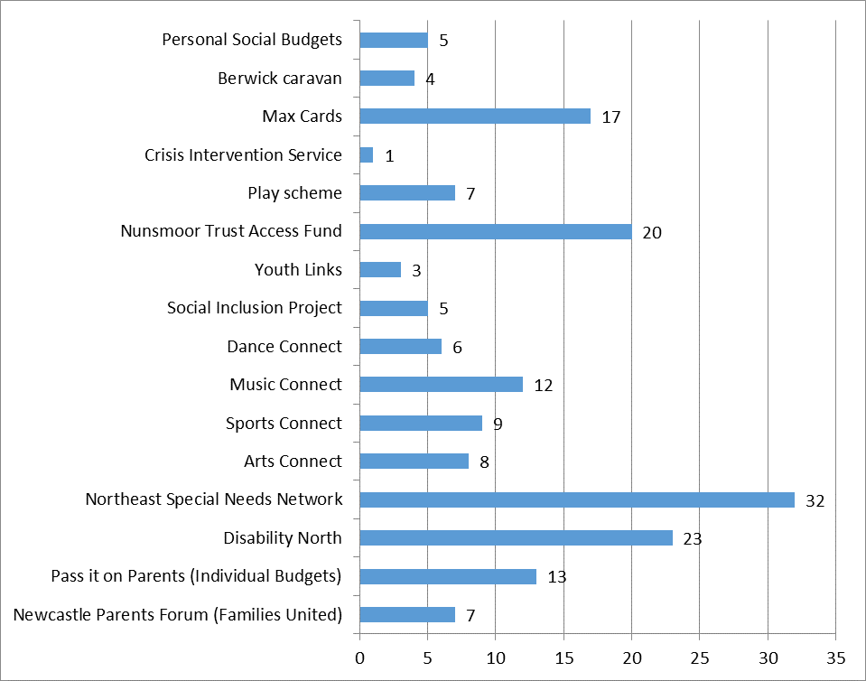

Table 5 - How much the provider listens to parents?
Analysis of parent feedback about Service Providers
Table 6 - Staff Survey
In the spring of 2015 a questionnaire was distributed to staff within the children with disabilities team, and providers of the short break offer. The questionnaire asked about the services on offer and what improvements if any, they would like to see. From the graph below it is apparent that staff and providers value “Get Connected” activities and the information and advice services.

Staff would like more clarity between Pass-it-on-Parents and the Parents Forum as they currently see some duplication in service. Staff would like to see quicker response time to requests for mentoring support for young people.

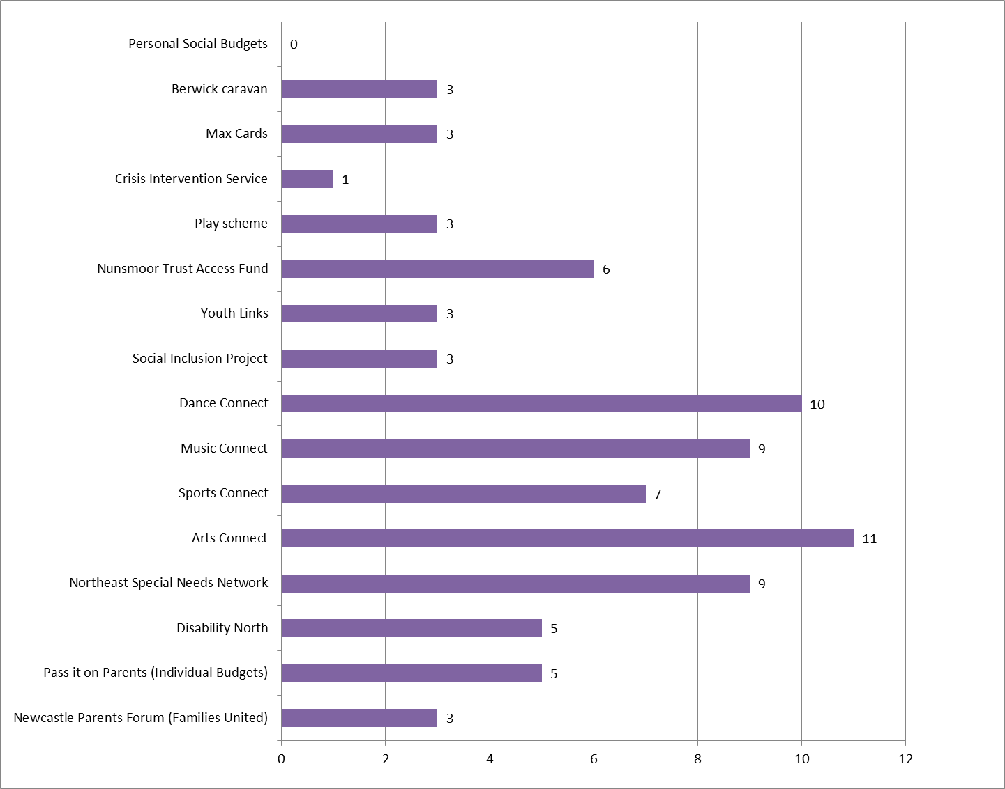

Feedback from Parents
In the spring of 2015 a questionnaire was distributed to all parents with a child /young person on the disabled children’s register.
We like Information and advice services, we think these services as a valuable resource.

We would like more fully inclusive supported activities during school holidays.

Sixty eight parents completed a questionnaire about the current short break and support service offer.

The council aske parents about the services that are on the currently on offer and what improvements if any, they would like to see.

Table 4 tells us that parents use the information and advice services the most, they value these services, find them easy to access and regard them as a really good resource.
Can we have more Activities for young people aged 16 and upwards.

Parents told us they would like to see more resources going into the Access Fund, for information and advice services and for youth provision for 16+ young people
It would be great if we could continue to be supported till 18 in this service.’
The questionnaire analysis showed told us:

Some parents feel the current play scheme on offer is not suitable for their children. Doesn’t always help children who aren’t interested in dance, music art, and sport.”

One parent said the current offer is not suitable for everyone and “Doesn’t always help children who aren’t interested in dance, music art, and sport.”

The intention to grow the access fund and the establishment of Personal Budgets are intended to address the challenges raised in the parent’s feedback

Many parents are satisfied with the services offered, but feel provision for young adults could be improved including continuing support and services through to 18.

Overall parents felt that providers do listen to them and their child’s wishes. Services and support which parents think is missing include more activities and support for older children, and transitional services for when disabled children move from childhood into adulthood.

What will we do?
Commissioning for outcomes

A key element of the Council’s strategy for future provision of services, this approach puts the service user at the centre of the process, where they specify when and how the service should be delivered.
Outcome focused services are designed to support personalisation. They enable service users to achieve their aspirations, goals and priorities.
This approach shifts the focus of provider’s activities to meeting outcomes by accommodating the choices and preferences of the service user with innovative, flexible and creative support.
Success of the service is measured by whether the service user is satisfied and outcomes are met.
To support working towards outcomes, Newcastle City Council is promoting the use of Individual Service Funds (ISFs).
ISF is an arrangement where in addition to providing direct support under a contract with the local authority, the Service Provider agrees to manage the personal budget on behalf of the Service User, only spending it in the way agreed and described in support plan
It gives people greater choice and control over the design and implementation of the support provided to them, giving them more flexibility to achieve outcomes that matter to them.
ISF’s rely on a relationship with a high level of trust between the Local Authority, the Service Provider, the Service User and their Carer.

The council will review how the market for disabled children needs to re-shape for the future, this will happen over late summer and into autumn 2016 in addition we will:

- Maintain services to support and promote inclusion of disabled children and where possible expand the range of opportunities and support

- Continue to develop the service that works with families of disabled children in crisis. This provision is currently operating at full capacity. We acknowledge this is a valued service but the delivery model must be reviewed to ensure needs are met within the funding available. Our next review in autumn 2016 will address these issues.

- We will also review the information, advice and guidance services at the same time as above to develop a service to meet the changing needs of families and cope with the growing numbers and demand for this type of support.

- The Enablement and Short Breaks framework will be recommissioned in the form of a community short breaks lot within a wider life course framework which will be published August/ September 2016.

The overall financial package available to support “Personal Budgets” taken as a direct payment is approximately £800,000 per annum for the 170 children.

Of the 170 children using personal budgets it is anticipated that 89% will choose a direct payment, and 11% of Personal Budgets will be managed on their behalf by the Council.

Commissioned services activity is approximately £100,000 per year for the Enabling, Short Break and Support Services

The chart below represents the split of the £900,000 funding that collectively supports Children with Disabilities Care Packages

Care Package Finances

Those families who have asked the city council to manage their personal budget and secure commissioned services is approximately £100,000 for the Enabling, Short Break and Support Services.

Therefore the Framework contract with OfSTED and Care Quality Commission registered services will be approximately £300,000over the life of the 3-year Framework.

Contacts

Write to:
Commissioning and Procurement
Room 104
Newcastle City Council
Civic Centre
Barras Bridge
Newcastle upon Tyne
NE1 8QH

Martin Donkin Social Work Senior Practitioner martin.donkin@newcastle.gov.uk

Tel. 0191 2277 4700

Michael Satchell Commissioning and Procurement Officer michael.satchell@newcastle.gov.uk Tel. 0191 211 5349

